tinyurl.com/LamarWritingLab

IB Sports, Exercise and Health Science
Internal Assessment: Scientific Investigation

The internal assessment task will be one scientific investigation 6–12 pages long.

The five assessment criteria are:
Personal engagement [2]
Exploration [6]
Analysis [6]
Evaluation [6]
Communication [4]
=24
Document Structure
IMRaD Scientific Publication Structure | IA Sections
Introduction | Research Question, Background Information, Hypothesis
Methods | Variables, Materials, Procedures
Results | Data tables, Data processing/analysis, Findings
And Discussion | Evaluation

Scientific Investigation Breakdown
Section | Description, Tips | Example(s), phrases
Exploration criterion [6] | This criterion assesses the extent to which the student establishes the scientific context for the work, states a clear and focused research question and uses concepts and techniques appropriate to the Diploma Programme level. Where appropriate, this criterion also assesses awareness of safety, environmental and ethical considerations.  • In Exploration, Personal Engagement (PE) [2] can be shown by developing a unique research question, with detail in the background research, the creation of a unique methodology, or by showing evidence of careful consideration of control and confounding variables. | For full marks:  The topic of the investigation is identified and a relevant and fully focused research question is clearly described.  The background information provided for the investigation is entirely appropriate and relevant and enhances the understanding of the context of the investigation.  The methodology of the investigation is highly appropriate to address the research question because it takes into consideration all, or nearly all, of the significant factors that may influence the relevance, reliability and sufficiency of the collected data.  The report shows evidence of full awareness of the significant safety, ethical or environmental issues that are relevant to the methodology of the investigation*.  * This indicator should only be applied when appropriate to the investigation.
Research Question | Good research questions identify the independent variable and the dependent variable (with units of measurement or specifications if possible).  Your research question indicates the type of investigation you’re going to do. This is the question you will answer in your evaluation.  Questions with an asterisk * are correlation research questions, for which you measure rather than manipulate variables, and examine the relationship between them.  Questions with a caret ^ are causation research questions, for which you manipulate one independent variable to see the effect this has on another, the dependent variable, and examine the relationship between cause and effect.  (see Sproule 337) | Examples  To what extent does personality differ in team versus individual athletes? (example 8)  The effect of different types of feedback on novice athletes taking a penalty kick in football?^  The extent to which internal air pressure of basketball affects the height of the first bounce?^  After a standardized exercise test, is the rate at which heart rate (bpm) returns to the pre-exercise level different for trained and untrained individuals? (Sproule 338)  How does tennis serve success differ between using a static stretching and dynamic stretching warm-up for female varsity tennis players? (example 9)  Phrase Bank  To what extent does ____ impact ____?*  Does ____ affect ____ when using ___?^  How does using ____ increase/decrease ____?^  To what extent does ____ differ in ____?*
Background Information | ~400-500 words:  Defining the variables and key terms in relevant context using academic sources;  Discussing two or more previous studies, their methods, findings, and significance of their study for your exploration.  Subject Report May 2021, Personal Engagement [2]:  Students had success where teachers encourage and support student work with original research questions that are justified using scientific background information and provide depth across the entire report.  Exploration [6] criterion:  The background information provided for the investigation is entirely appropriate and relevant and enhances the understanding of the context of the investigation.  Research Tips for finding appropriate and relevant academic sources/studies  ↓ ↓ ↓  Guide to accessing academic databases using Houston Public Library    Try putting your research question into free AI research tool Elicit.org to find relevant scientific studies. Elicit will generate a summary of the top 4 articles in the search results, which you can use to identify relevant sources to look into further. The Filters menu allows you to limit the results to only those with linked PDFs you can access and read yourself for free. (See screenshot below)  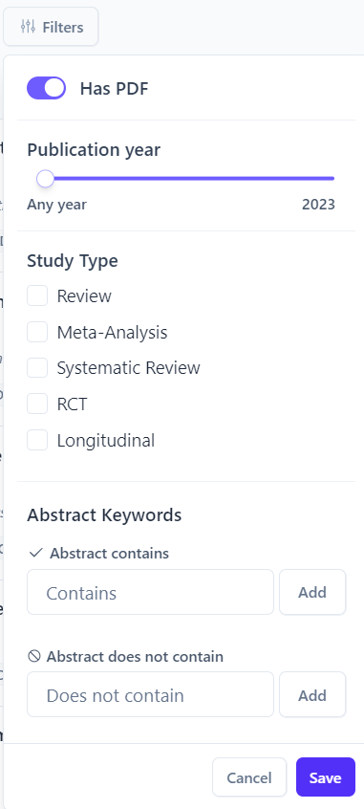    Or, check out Consensus.app, another AI research tool that allows you to input your research question and returns scientific studies with potentially relevant answers. | From IB example 9:  Warm-up routines prior to exercise increase muscle and tendon flexibility, stimulate blood flow through the body, increase body temperature, and enhance movement. However, warm-up routines consisting of static stretching activities have different effects on the body than those of dynamic stretching activities. A static stretch is done through placing muscles at their greatest possible length and holding that position for a period of time. However, a dynamic stretch involves smooth, controlled moving of a limb from its neutral position to end range (muscles are at greatest length), and then returning to original position. Static warm-up (SWU) routines increase flexibility, decrease musculotendinous stiffness, reduces neural activation and delayed-onset muscle soreness (DOMS) according to McMillian et al. (2006). On the other hand, dynamic warm-up (DWU) routines increase pliability of joints and muscles, and responsiveness of nerves and muscles in preparation for physical readiness training activities, and are used as an attempt to decrease injuries and increase physical performance as stated by Gelen et al. (2012).  McMillian et al. found that a DWU consisting of exercises of squats, power jumps, push-ups, laterals, and shuttle sprints held a performance enhancement within the t-drill agility test and medicine ball throw power test, whereas there was no significant difference on performance enhancement between having a SWU or no warm-up. An active warm-up as the DWU was thought to enhance short-term performance because of resulting decreased stiffness in muscles and joints, increased transmission rate of nerve impulses, changes in force-velocity relationships, etc. However, static stretching was found to produce greater stretch tolerance accounting for an increased range of motion. Since for tennis serves, both an extensive range of motion and power are necessary for a successful performance, the contrasting effects of a SWU and DWU become conflicting on which warm-up is more suitable.  Moreover, Chatzopoulos et al. (2014) concluded that a SWU has a negative effect on balance, agility, and movement time in comparison a DWU through testing three variables: "(a) 3 min jogging followed by 7 min static stretching (SS), (b) 3 min jogging followed by 7 min dynamic stretching (DS), and (c) 3 min jogging followed by 7 min of rest (NS)." Balance is a significant factor in tennis serves when waiting for the connect time to strike the ball with proper aim. SS was found to be detrimental to maximal strength performance and speed, both necessary for the fast and accurate movements for maintaining balance in tennis while DS enhanced muscle performance because of elevated muscle temperatures stimulating the nervous system. No significant difference was found between SS and OS on reaction time. Such indicates that dynamic stretching offers improvement in balance which is fundamental for successful serves in tennis.  The objective of this study is to differentiate whether a static warm-up or dynamic warm-up is more effective in producing successful tennis serves (make it in the service box).  Phrases for Defining terms  Phrases for writing about past studies  Phrases for Comparing and contrasting previous studies  Phrases for Explaining causality
Hypothesis | Experimental hypotheses propose an outcome that will either be supported or rejected by the actual data gathered in the course of the experiment.  Based on your background research, what do you expect to observe in the results of your experiment?  - State the predicted outcome of your study clearly, referring to the particular variables and precise data to be collected. Be sure to use the future tense (“will”) since it’s a prediction.  - Give a brief explanation of your reasoning for the prediction and expected answer to your research question.  The hypothesis should match up with the data you will collect and analyze, and be consistent with your correlation- or causation-type research question.  To ensure that an experimental hypothesis predicts a significant outcome, scientists include a complementary null hypothesis, stating the case in which no significant outcome is observed. | The classic hypothesis model  If ________ (independent variable), then __________ (dependent variable).  If this independent variable is manipulated/present, then the dependent variable will be significantly different in this specific way (than when the independent variable is unchanged/absent/converse).  Example  Tennis players using a dynamic warm-up (DWU) will have a higher number of successful serves out of ten serves than when using a static warm-up (SWU). If a group of female varsity tennis players use a warm-up characterized by dynamic stretching activities, then they will have a higher number of successful serves in a total of ten serves than when using a warm-up consisting of static stretching…(example 9)
Variables | List your independent and dependent variables.  Independent Variable (IV) - the factor you change or manipulate to see if it makes a difference  Dependent Variable (DV) - the thing you measure in order to support or reject the hypothesized difference  Controlled Variables - factors that can be controlled and monitored  Include a table or list of your controlled variables, identify how they might impact the DV, and how it will be controlled during the experiment.  Confounding Variables - cannot be controlled but need to be monitored  List your confounding variables and how you will monitor them, including qualitative data observations you might record during the experiment so that you can account for how confounding variables might affect your data.
Materials | In a table(s) or list(s), provide resources, facilities, instruments, documents, software, and other materials used in the production and recording of data.  Indicate precise dimensions, versions, and material compositions when appropriate so that your reader could accurately replicate your procedure.  Include diagrams and/or images when they aid in accurate identification and replication of materials or facilities used in the collection or processing of data.
Procedure | Using past tense, list in sequence the steps by which the experiment and data collection may be replicated as exactly as possible.  Providing precise numbers, locations, units, and timelines when appropriate, clearly indicate:  - the research setup,  - participant or data sampling/collection,  - when and how materials are used, taking and recording measurements,  - maintenance of controls,  - monitoring of confounding variables,  - calculations,  - and other practical or scientific processes employed.  Reference the table or appendix in which the raw data is recorded.  Reference where copies of consent forms, surveys or questionnaires, and other important documentation can be found in the Appendices.  Include diagrams and/or images when they aid in accurate identification and replication of procedure used in the collection or processing of data.  Phrase bank for Describing Methods  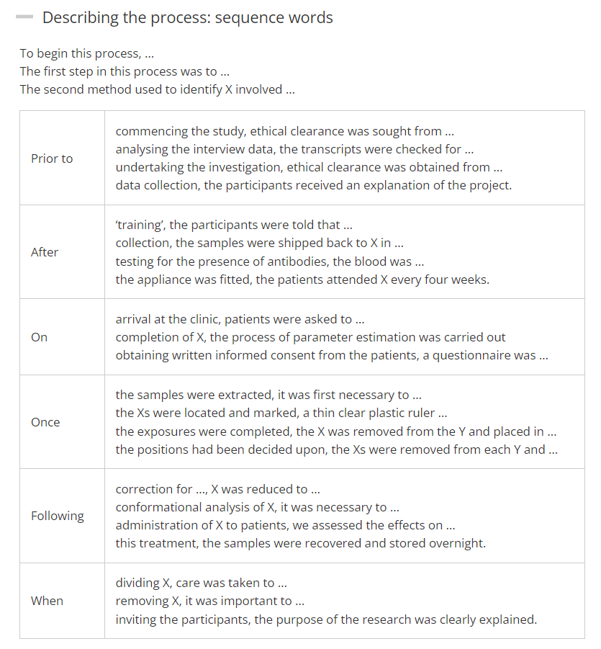  Data Sources and Collection  primary sources were: secondary sources included … an extensive database  to collect data on …  We obtained data on … from …  Data on … were collected …  … by … … between … and … … during … … at regular intervals … … continuously  The data were or are compiled from a number of or several sources  Continuous measurements of … were made …  Sampling of … was carried out over a two-week etc. period in ___.  Conditions during the sampling period were …  a random sample of … … selected or chosen at random from …  … randomly selected from … … provides a representative sample of …  It is estimated that there are …
Data | Quantitative:  Provide a labeled table of the raw data collected; appropriately indicate units of measurement and rounded values.  If recorded data is sufficiently lengthy, include a sample of the data in the body of the report and the full data set in an appendix.  Qualitative:  Note qualitative data that could help or hinder answering the research question.  → Subject Report May 2022:  Collecting qualitative data is important. For a higher grade, this data should be referred to in the analysis.  “The qualitative data needs to be relevant and should be specific to individual subjects where possible. General statements such as ‘it was cloudy’ offer little value. Selecting appropriate qualitative data to collect is part of a good design process.  It should be evident that the size and scope of the data collected is sufficient for the data processing and analysis you perform.  → See “Tips for data collection and using tables” box in your textbook → Sproule 340. | Present the raw data you collected in a standard table form.  Format your tables with each group represented in a row, and your findings presented in the corresponding columns.  Title your table and include complete labels for rows and columns, as well as units when presenting quantitative (numerical) data. Use separate columns if there are multiple trials or measurements for each group. Make sure each data point is presented in a consistent form to allow for objective comparison.  Then, describe the findings your data represents, drawing attention to differences or trends you observed:  “Table [X] shows…”  “The data presented in table [X] indicate…”  Phrases for Describing Quantities  Figures, tables and graphs  table X shows … figure X illustrates … as seen in figure X  as shown in the table above or below  examples of … are shown in figure or table X The image shows that …  The figures, data etc. … … are given above … are presented below  … are shown in table X … are listed above or below  … are summarized in figure or table X … are illustrated in figure X  … are illustrated in the figure, graph or table above or below  … are shown in the graph above or below … are shown in brackets or parentheses … are given in the appendix Figure X shows …  … the size of … … the level of …  … the extent of …  … the effect of … … the rate of …  … the concentration of …  … the distribution of … All values are given as …  each column represents …  The shaded area represents …  … based on the data given in table X  Values in brackets or parentheses are …  An alternative way of presenting … is to …
Analysis [6]  This criterion assesses the extent to which the student’s report provides evidence that the student has selected, recorded, processed and interpreted the data in ways that are relevant to the research question and can support a conclusion. | Apply and explain the processes and calculations by which you analyze the data, the results represented by additional well-labeled tables, graphs, diagrams, equations, numerical values, screenshots, charts, etc. (i.e., “graphical displays”)  Indicate where programs/technology were used for data processing or presentation.  Clearly define and/or thoroughly label all components, variables, values and units for calculations and images, such as tables and graphs, included in the body of the report and appendices.  Discuss contradictions, outliers, ambiguities, contrasts and trends in data or results.  Explain and interpret the results or outcomes observed in your data analysis.  Subject Report May 2022:  Within the Analysis, PE can be shown with rigour in the data collection or by taking the analysis of the data beyond the expectations of the subject guide, in a way that is justified. | Phrase Banks  Formula or equation  To determine ______, the following formula is used:  $Y=x^{2}+v$  where Y is ____ in [units], x is _____ in [units], and v is ____ in [units].  We can calculate _______ with the function  $f(x)=x^{2}+v$  where x is _____ in [units], and v is ____ in [units].  Definitions, notation and terminology  the types of … in terms of …  with reference to …  this formula allows us to …  We defined … as …  By … we mean … By … is meant …  … is defined as … … can be defined as … … is or are often defined as …  … are defined in this study as follows:  … can be characterized as … … can be formulated as follows:  … denotes … … represents … is representative of …  …, which is or are represented here by or as … … can be written as …  Presenting Data Results  … can be expressed more simply as …  … is or was determined as follows: … is or was measured by …  … is or was calculated as follows: … is or was calculated by …  where … is the … represents denotes  The proportion of … ranged from … to … ranging from … to …  … ranked in order of … … is proportional to …  … was significantly higher in … than in … … was significantly lower in …  … peaked at … … was higher than expected  … was lower than expected the expected number of …  Phrase bank for Reporting Results (Data)  Analysis and discussion  to examine … to examine … more closely to observe … to observe … in detail  to evaluate … to assess … to assess the significance of … In determining …, …  to determine whether … whether or not … We observed … By analyzing …,  … was analyzed by or for … The analysis here is based on …  It is relatively easy to describe …  one immediately obvious feature of … is …  A quick glance at … shows that …  … exhibit classic signs or symptoms of …  From … it is apparent that …  … is immediately apparent … is most pronounced in … … shows evidence of …  Superficially at least, … Underlying … is the view etc. that …  Analysis of the data revealed …  Closer examination of … reveals that …  Closer inspection revealed that …  Viewed in this way, …  There is some indication that …  Observations of … suggest that …  The presence of … can be tested by … An important test for … is whether or not …  … may be or is confirmed by …  … tends to occur or be found in …  exposure to … results in …  One way of examining or viewing …  Phrases for describing trends in data  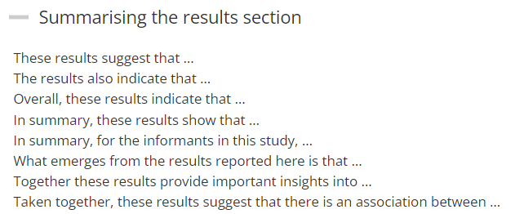
Evaluation [6]  This criterion assesses the extent to which the student’s report provides evidence of evaluation of the investigation and the results with regard to the research question and the accepted scientific context. | Answer your research question and explain that concluding answer based on your data and results. Consider your results in the scientific context (that you first referenced in the background information section).  Subject Report May 2022:  • Under Evaluation, candidates can display Personal Engagement by outlining the practical implication(s) of their findings to the sporting /health environment.  Don’t just redescribe your results; explain them:  Discuss trends you observed in your data, including unexpected results or if data does not show a clear pattern.  Compare your results to your expectations based on background research and findings of others.  Explain your results in the context of the scientific literature on the topic.  Does your data support or diverge from what others have shown?  How might the reliability of your study be limited? What suggestions do you have for improving reliability?  ~ “Reliability is the extent to which the same reading is obtained each time a variable is measured” (Sproule 341).  [limitations of method of measurement]  How might the validity of your study be limited? What suggestions do you have for improving validity?  ~“Validity is the extent to which the measure actually measures what it claims to” (Sproule 341).  [qualitative factors that may influence what’s measured] | Phrase Banks  Discussing results  - This study found that …  - Another finding is that …  - The results of this study show that …  - The current investigation found that …  - In this study, Xs were found to cause …  - On the question of X, this study found that …  - The first part of the questionnaire revealed that …  - This experiment did not detect any evidence for …  - The most obvious finding to emerge from the analysis is that …  Comparing the results  Supporting previous studies  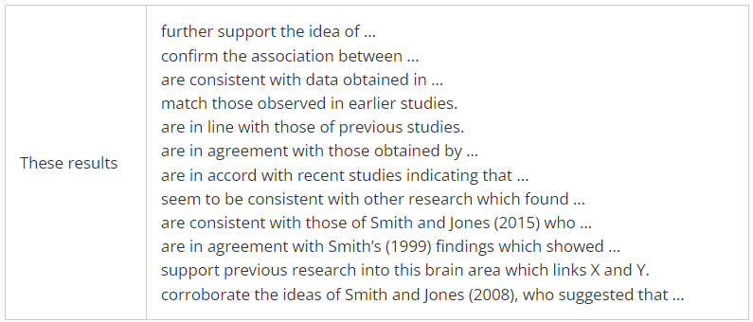  Contradicting previous studies  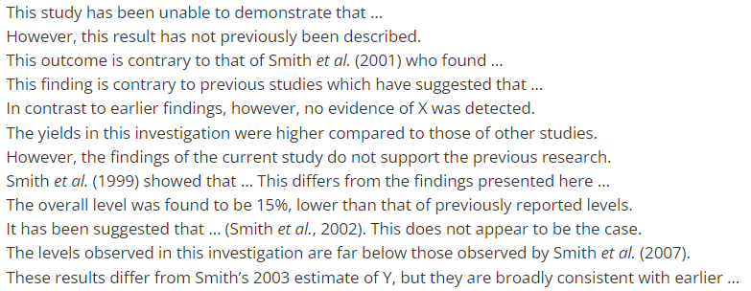  Recognizing limitations of your study  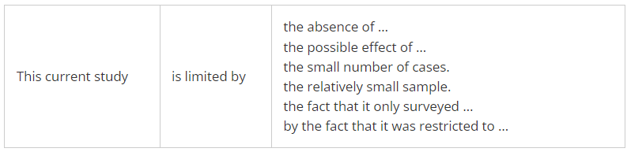  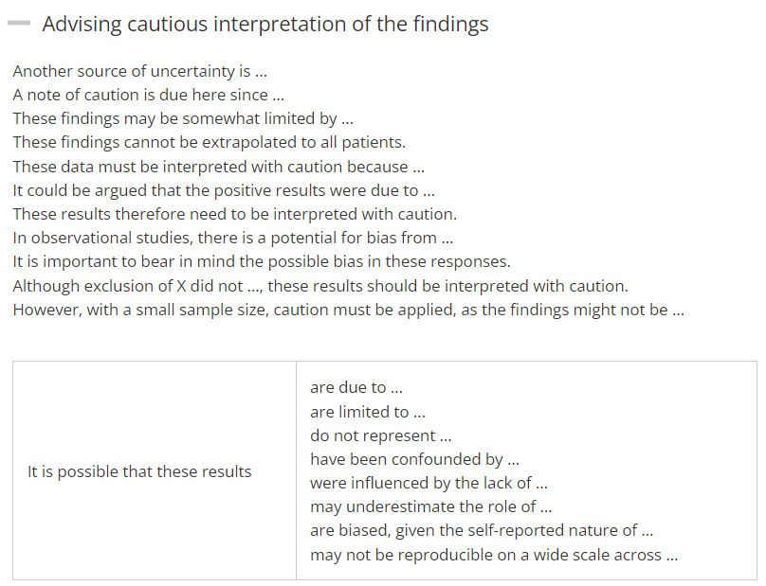  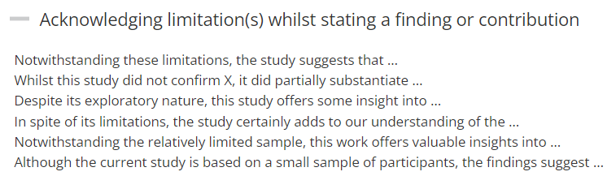  Evaluation and discussion of process  The experiment was designed to …  The advantage of this approach is that …  This approach has a number of advantages: firstly, …  … gives a better basis for … it combines … with or and …  This format allows us to see more clearly how …  In this way, we are able to eliminate several of the problems of previous approaches or methods  One difficulty in … is … A or one significant problem is …  Coordination of … and … is essential or particularly difficult a compromise  One strategy would be to … … avoids this difficulty by …  the practical problems involved in … an alternative way of approaching the problem  Another way of looking at the question of …  Evaluating and discussing significance and limitations  The importance of … is demonstrated by the fact that …  … assumes a special significance because or as …  One of the most obvious consequences of … is  the/an important observation that … A point that can be made is that …  This may be discussed in terms of … … is perhaps best viewed as …  If this is the case, then … This attests to … This agrees with …  … is or are, in effect, … … supports the notion that … … may be inferred from …  This would suggest that … There is some evidence to suggest that  The question arises whether … It is an open question whether …  This raises a further question: This raises the issue whether …  This raises a number of questions.  One may question whether …  a number of reservations/limitations  One cause for concern is …  It is not necessarily the case that …  it would be more accurate to say that …  a more promising approach would be …  a more plausible explanation would be that …  … must be examined more closely  … cannot be accepted as it stands  more needs to be said about …  However, given these reservations, …  Despite these reservations, …  Despite these limitations, …  Given these qualifications, …  Explaining and evaluating alternative Interpretations  Other possible explanations or causes are …  An alternative explanation would be …  One possible explanation for … is …  A more plausible explanation for … would be that …  One may question whether …  a number of reservations/limitations  One cause for concern is …  It is not necessarily the case that …  it would be more accurate to say that …  a more promising approach would be …  a more plausible explanation would be that …  … must be examined more closely  … cannot be accepted as it stands  more needs to be said about …  However, given these reservations, …  Despite these reservations, …  Despite these limitations, …  Given these qualifications, …  Other possible explanations or causes are …  An alternative explanation would be …  One possible explanation for … is …  A more plausible explanation for … would be that …  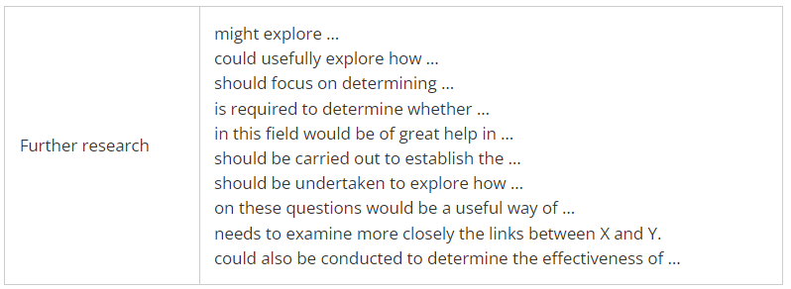  Phrases for being cautious when discussing and evaluating results  Phrases for critical evaluation  Phrases for writing about the past/what happened
Bibliography
PurdueOWL MLA Guide and Citation Generator
Appendices

- Blank Consent form, if using human participants
- Script for spoken directions, if using human participants
- Full data table, if applicable
- Qualitative data collected during experiment (observations, typically addressing potentially confounding variables)

IA Grading Criteria
Personal engagement [2]
This criterion assesses the extent to which the student engages with the exploration and makes it his or her own. Personal engagement may be recognized in different attributes and skills. These could include addressing personal interests or showing evidence of independent thinking, creativity or initiative in the designing, implementation or presentation of the investigation.

Top Marks:
- The evidence of personal engagement with the exploration is clear with significant independent thinking, initiative or creativity.
- The justification given for choosing the research question and/or the topic under investigation demonstrates personal significance, interest or curiosity.
- There is evidence of personal input and initiative in the designing, implementation or presentation of the investigation.

Subject Report May 2022
The PE criterion was often over-assessed, as it is misunderstood as showing interest in, or having a link to the topic. Students had success where teachers encourage and support student work with original research questions that are justified using scientific background information and provide depth across the entire report.
Personal engagement is shown over the entire report and to attain two marks for this criterion, students must fully engage with the topic. Students should choose a topic that is of genuine interest to them. It is usually obvious to an examiner when a student genuinely cares about their research topic, therefore students need not include a paragraph that explains why the topic was chosen.

Exploration [6]
This criterion assesses the extent to which the student establishes the scientific context for the work, states a clear and focused research question and uses concepts and techniques appropriate to the Diploma Programme level. Where appropriate, this criterion also assesses awareness of safety, environmental and ethical considerations.

Top Marks:
The topic of the investigation is identified and a relevant and fully focused research question is clearly described.
- The background information provided for the investigation is entirely appropriate and relevant and enhances the understanding of the context of the investigation.
- The methodology of the investigation is highly appropriate to address the research question because it takes into consideration all, or nearly all, of the significant factors that may influence the relevance, reliability and sufficiency of the collected data.
- The report shows evidence of full awareness of the significant safety, ethical or environmental issues that are relevant to the methodology of the investigation*.
* This indicator should only be applied when appropriate to the investigation. See exemplars in the teacher support material.

Analysis [6]
This criterion assesses the extent to which the student’s report provides evidence that the student has selected, recorded, processed and interpreted the data in ways that are relevant to the research question and can support a conclusion.

Top Marks:
- The report includes sufficient relevant quantitative and qualitative raw data that could support a detailed and valid conclusion to the research question.
- Appropriate and sufficient data processing is carried out with the accuracy required to enable a conclusion to the research question to be drawn that is fully consistent with the experimental data.
- The report shows evidence of full and appropriate consideration of the impact of measurement uncertainty on the analysis.
- The processed data is correctly interpreted so that a completely valid and detailed conclusion to the research question can be deduced.

Evaluation [6]
This criterion assesses the extent to which the student’s report provides evidence of evaluation of the investigation and the results with regard to the research question and the accepted scientific context.

Top Marks:
- A detailed conclusion is described and justified which is entirely relevant to the research question and fully supported by the data presented.
- A conclusion is correctly described and justified through relevant comparison to the accepted scientific context.
- Strengths and weaknesses of the investigation, such as limitations of the data and sources of error, are discussed and provide evidence of a clear understanding of the methodological issues* involved in establishing the conclusion.
- The student has discussed realistic and relevant suggestions for the improvement and extension of the investigation.
* See exemplars in the teacher support material for clarification.

Communication [4]
This criterion assesses whether the investigation is presented and reported in a way that supports effective communication of the focus, process and outcomes.

Top Marks:
- The presentation of the investigation is clear. Any errors do not hamper understanding of the focus, process and outcomes.
- The report is well structured and clear: the necessary information on focus, process and outcomes is present and presented in a coherent way.
- The report is relevant and concise thereby facilitating a ready understanding of the focus, process and outcomes of the investigation.
- The use of subject-specific terminology and conventions is appropriate and correct. Any errors do not hamper understanding.

